BALLOT BOX BINS

Many people assume discarded cigarette butts break down over time. However, most cigarette filters are made from a plastic-like material, cellulose acetate. When tossed overboard or washed into storm drains, creeks and waterways, this material can last for decades harming fish and other wildlife.
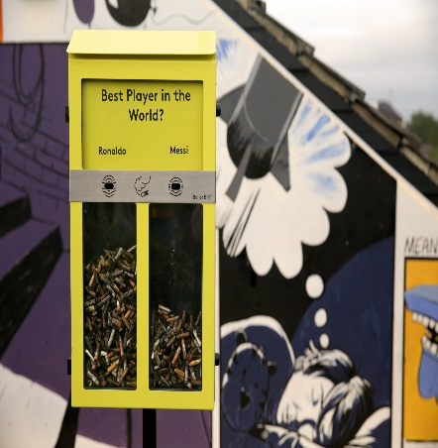
The Wicomico Environmental Trust (WET) has partnered with Keep America Beautiful to clean up cigarette litter in Salisbury. Ten boxes (as seen here) have been installed in the city along with a question for smokers to weigh in on by voting with their litter. Discarded cigarette litter will be collected and will be recycled into plastic industrial pallets. In January, public service announcements will be aired on Public Access Channel 14 and students from local schools will participate in poster contests illustrating the negative effects of discarding cigarette litter improperly.
A campaign is also underway to distribute portable ashtrays to local eateries and businesses. Help us clean up Salisbury and recycle cigarette litter into usable materials.

